VULNERABILITY ASSESSMENT & PENETRATION TESTING REPORT
Before You Agree - Iteration 1
Date: 3 September 2026
Scope: Vue frontend, Node.js API, npm dependencies, AWS Amplify response headers and relevant source code
Prepared by: Raj Tandel

Table Of Contents
Index | Content | Page
1 | Purpose and method | 2
2 | Test evidence | 2-3
3 | Findings | 3-4
4 | Implemented Controls | 4-5
5 | Limitations | 5
6 | Retest plan | 5
7 | Pen Test Findings | 5-6
8 | Evidence screenshots | 7-11
9 | Impact Assessment | 12
10 | Recommendations | 13
11 | References | 14

1. Purpose and method
We reviewed the source code and npm dependencies, checked the deployed frontend and API, and used OWASP ZAP, Burp Suite, Nmap and DirBuster against systems controlled by the team. We did not deliberately attempt denial of service or attack ToS;DR, GitHub or OpenTermsArchive. The DirBuster run nevertheless produced a high request rate, so it is treated as an inconclusive test and should not be repeated against the deployment without a strict request limit.
- Source review against common OWASP API risks such as resource consumption, security misconfiguration, SSRF and unsafe third-party API use.
- Dependency check with npm audit.
- Local API checks for CORS, invalid IDs, unsupported methods, empty analysis input and basic security headers.
- Deployed HTTPS and response-header check for the Amplify frontend.

2. Test evidence
Check | Actual result | Meaning
npm audit | 0 known vulnerabilities | No known npm advisory affected the installed dependency tree at the time of the check.
API health | HTTP 200 | The local API started and responded normally.
Allowed CORS origin | HTTP 200 and exact Amplify origin returned | The deployed Railway API allows the configured Amplify frontend origin. This confirms production CORS configuration for that origin, but CORS is not authentication.
Attacker CORS origin | No allow-origin header | An arbitrary origin was not trusted.
Invalid service ID | HTTP 400 | Non-numeric IDs were rejected before an upstream request.
Unsupported DELETE request | HTTP 405 | The tested version endpoint rejected DELETE and returned a short generic error.
Empty analysis content | HTTP 400 | The API rejected an empty analysis request.
API headers | nosniff; no-referrer on tested API responses | The API adds useful response protections. ZAP separately found that some frontend responses did not contain all expected browser headers.
Deployed frontend | HTTPS; HTTP 200 | Traffic to the Amplify site is encrypted in transit.
Frontend security headers | ZAP found missing CSP, anti-clickjacking and HSTS protections; SRI was also missing | The deployed frontend needs stronger browser security headers and safer handling of CDN resources.

3. Findings
ID | Finding | Rating | Evidence | Recommendation
VA-01 | Missing frontend browser security headers | Medium | OWASP ZAP reported Content-Security-Policy not set, missing anti-clickjacking protection and Strict-Transport-Security not set. It also reported X-Content-Type-Options missing on some responses. | Add CSP, HSTS, frame-ancestors/X-Frame-Options, Referrer-Policy and Permissions-Policy in Amplify.
VA-02 | In-memory rate limit can be bypassed by restart or multiple instances | Medium | requestBuckets is stored only in the Node.js process and uses socket addresses. | Use Railway/edge throttling or a shared store when scaling. Define trusted proxy handling.
VA-03 | Unbounded memory cache | Medium | responseCache has expiry timestamps but no maximum entries or active cleanup. | Add entry/byte limits and remove expired entries.
VA-04 | CDN assets do not use integrity attributes | Medium | OWASP ZAP reported a systemic Sub Resource Integrity attribute issue and cross-domain JavaScript. The frontend loads Bootstrap resources from jsDelivr without integrity values. | Self-host the required files or add verified integrity and crossorigin settings with CSP.
VA-05 | Production CORS allowlist verified | Resolved / verified | The Railway response returned Access-Control-Allow-Origin for the exact Amplify deployment origin, together with Vary: Origin. | Keep ALLOWED_ORIGINS restricted to approved deployments and retain a separate negative-origin test for each release. Do not treat CORS as user authentication.
VA-06 | External responses have limited schema and size validation | Medium | ToS;DR and GitHub JSON is type-cast at runtime; retrieved text does not have a separate response-size limit. | Validate response schemas and cap downloaded bytes before parsing or caching.
VA-07 | Limited security monitoring | Medium | A health endpoint and restart policy exist, but alert configuration was not found in the repository. | Add alerts for health failures, 5xx, 429, timeouts, memory use and dependency findings.
VA-08 | ML output may be misleading | Medium | The model produces a binary label and confidence, but policy wording can still cause false results. | Keep the disclaimer and original text, protect model integrity and document evaluation results.

4. Implemented Controls
- CORS rejected the unapproved test origin.
- Invalid identifiers, empty input and unsupported methods were rejected.
- The API returned nosniff and no-referrer headers.
- Remote requests use fixed domains, which reduces SSRF risk.
- Payload limits, request timeouts and per-IP rate limiting reduce resource abuse.
- Policy HTML is converted and escaped before display, which reduces XSS risk.
- No known npm vulnerabilities were reported at the time of testing.

5. Limitations
This is an Iteration 1 assessment, not a full penetration test. The screenshots record only the tested requests and the platform edge visible at the time. The Nmap result describes an AWS Amplify/CloudFront edge address, not every AWS origin host. The Burp tests are useful examples but do not prove that every possible payload is safe. DirBuster results are inconclusive because the single-page application returns the same index page for many unknown paths. External ToS;DR and GitHub services were not attacked or load-tested. Findings should be retested after changes.

6. Retest plan
After fixes, we will repeat the header, CORS, input, dependency and cache tests. We will record the new result, date, code commit and tester in the PGP and LeanKit. A finding will only be closed when there is evidence that the fix works.

7. Pen Test Findings
The following results are based on the screenshots stored in the Security Aspects/Evidence folder. A successful result means the tested behaviour worked; it does not prove that all attack variations are prevented.
ID | Result | Finding | What it signifies
EV-01 | Confirmed control | The API returned HTTP 200 and allowed the exact Amplify origin. Vary: Origin, nosniff and no-referrer were also present. | The production frontend can call the API while the allowlist remains origin-specific. This reduces unwanted browser-based cross-origin access, but it does not authenticate a caller.
EV-02 | Confirmed control | A DELETE request to a version endpoint returned HTTP 405 with a generic message. | Unsupported methods are rejected, reducing the exposed API behaviour
EV-03 | Confirmed for tested request | The traversal-style API path returned HTTP 404 and did not expose a file or internal path. | The router safely rejected this path and returned a generic error.
EV-04 | Confirmed for sampled payloads | Burp Intruder payloads shown in the screenshot received consistent HTTP 404 responses of similar length. | The tested route did not reveal internal information or produce visibly different behaviour.
EV-05 | Confirmed control | An unexpected search value returned HTTP 200 with an empty data array and no stack trace or internal error. | The search value was handled as data and failed safely without disclosing implementation details.
EV-06 | No unexpected edge ports observed | The tested Amplify/CloudFront edge address exposed ports 80 and 443; the remaining scanned ports were filtered. | Only expected web ports were visible at the tested CDN edge..
EV-07 | Open findings confirmed | ZAP reported missing CSP, anti-clickjacking protection, HSTS, SRI and other response-header observations. | Browser hardening is incomplete. Missing CSP and frame protection increase the possible impact of script injection and clickjacking; missing SRI weakens protection for third-party CDN files.
EV-08 | Inconclusive | Many guessed paths returned HTTP 200 with the same response size. The screenshot also shows hundreds of requests per second and a large request count. | Amplify's SPA fallback is likely returning index.html for unknown paths, so these are not proven directories.

Overall assessment: The deployed API handled the tested invalid routes, methods and search values without exposing internal details, and the production CORS origin is configured. Findings for rate limiting, cache bounds, external response validation, monitoring and ML reliability remain open and can be worked upon before final release.

8. Evidence screenshots
EV-01 - CORS
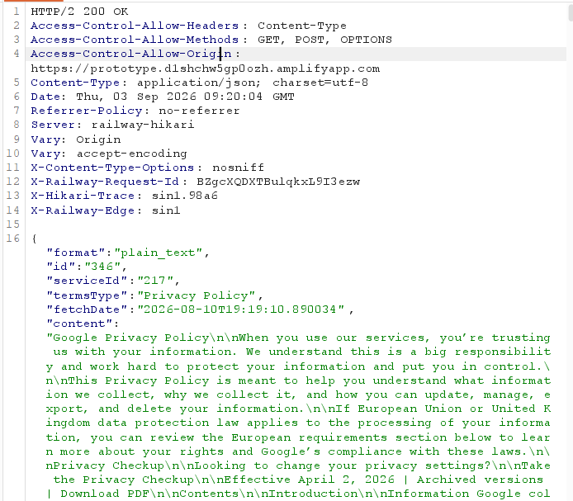
The production frontend can call the API while the allow list remains origin-specific. This reduces unwanted browser-based cross-origin access.
EV-02 Get Request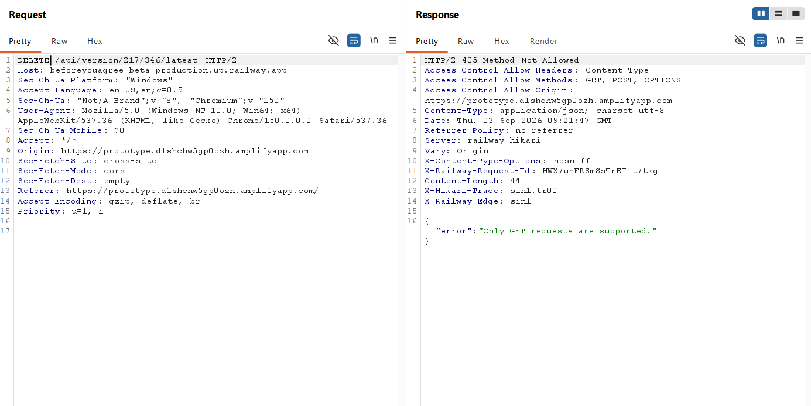

Unsupported methods are rejected, reducing the exposed API behaviour.
EV-03 - Api Traversal not allowed
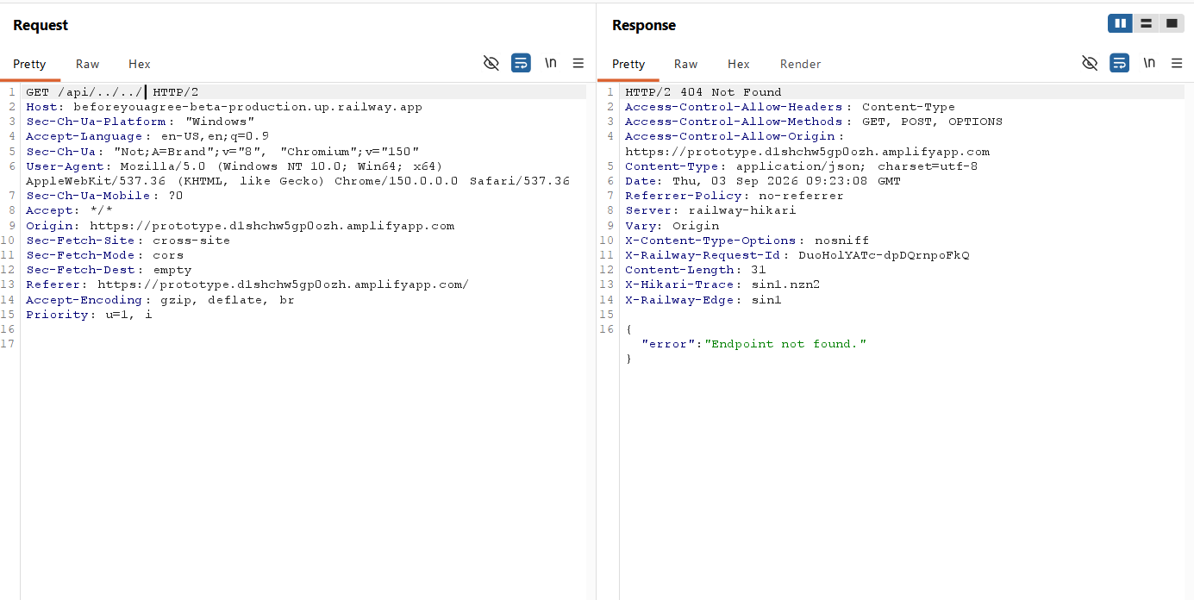
The router safely rejected this path and returned a generic error.

EV-04 - API fuzzing Does not Work
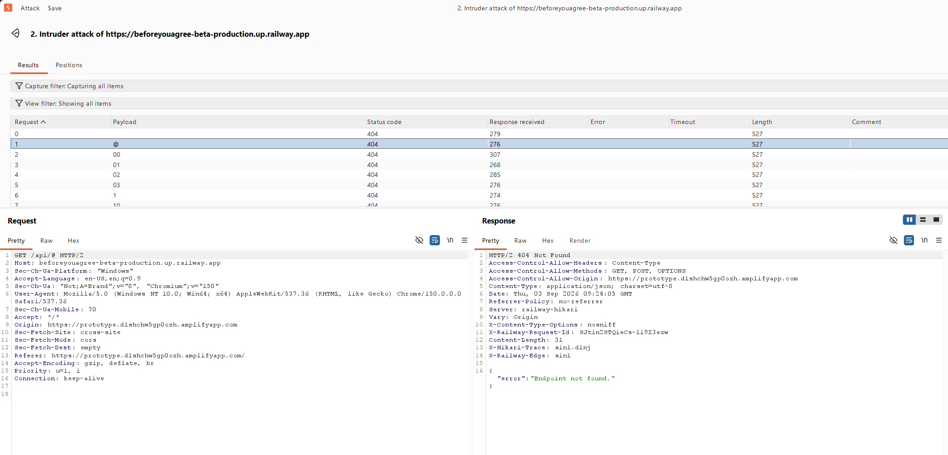
The tested route did not reveal internal information or produce visibly different behaviour.
EV-05 - Inavlid Data leaks no information
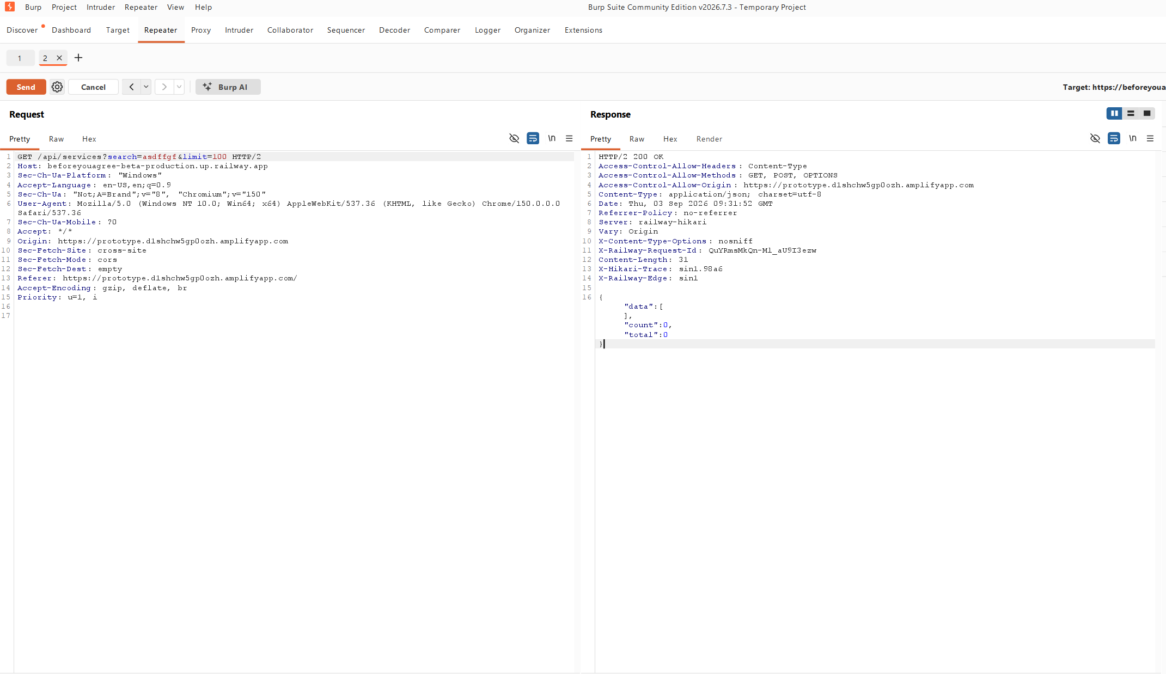
The search value was handled as data and failed safely without disclosing implementation details.

EV-06 - Nmap scan of deployed website
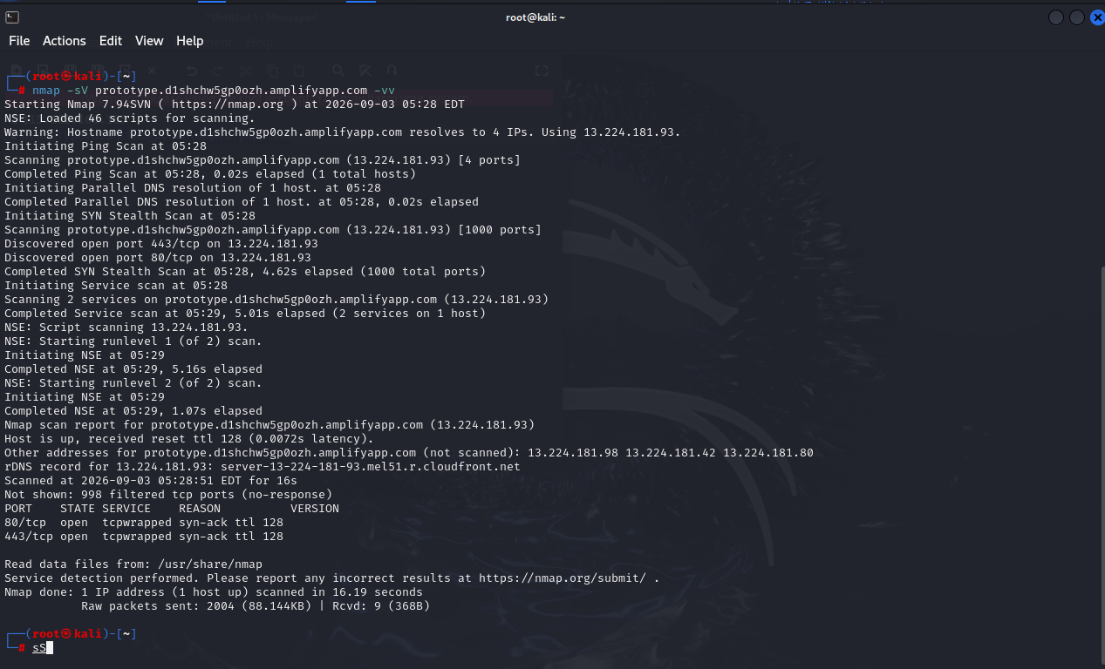
Only expected web ports were visible at the tested CDN edge.
EV-07 - ZAP screenshot showing CSP not implemented
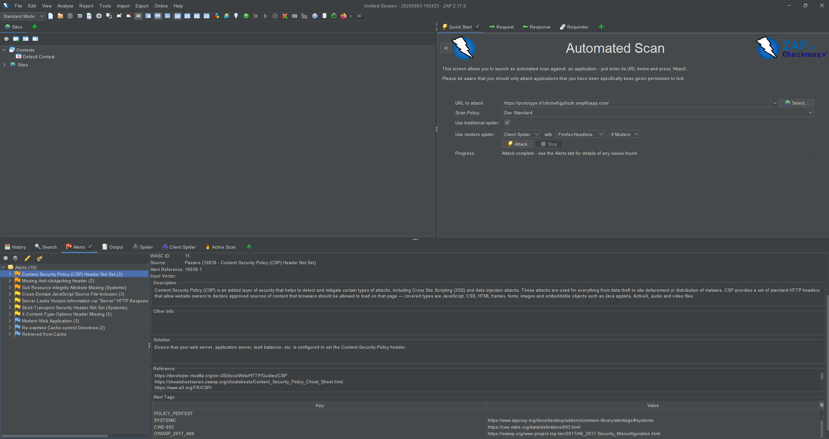
Browser security is incomplete. Missing CSP and frame protection increase the possible impact of script injection and clickjacking.

EV-08 - dIRbUSTER gives no real info
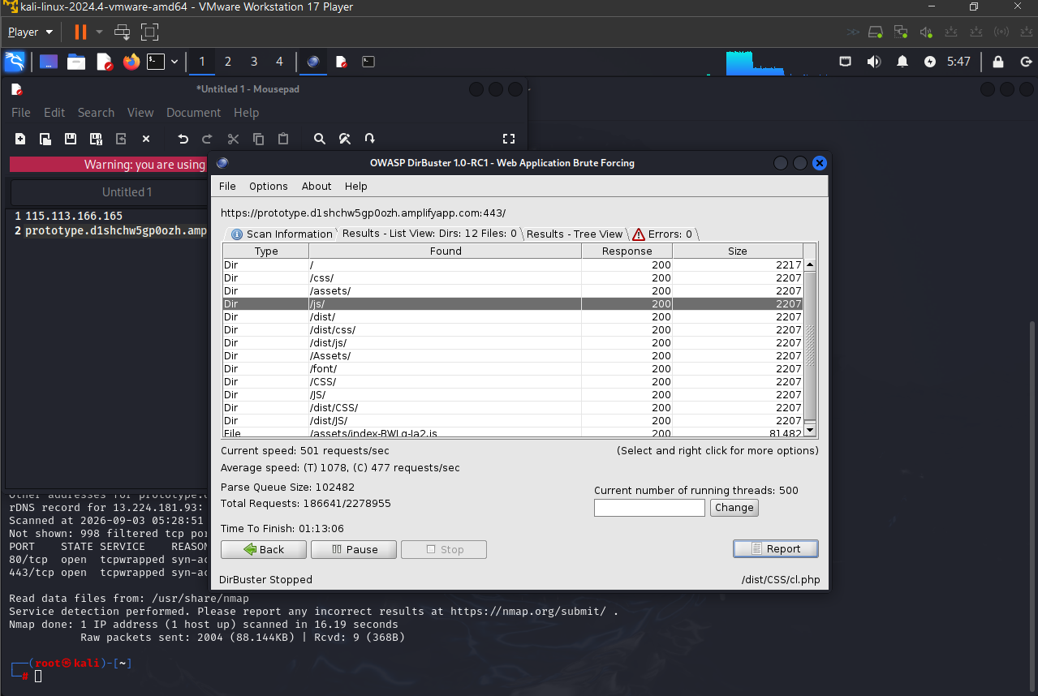
Amplify's SPA fallback is likely returning index.html for unknown paths, so these are not proven directories. The scan should not be used as evidence of hidden files, and future deployed scans must be rate-limited.

9. Impact Assessment
Confidentiality means keeping information private. Integrity means keeping information and results correct. Availability means keeping the system working and accessible. The ratings below describe the possible effect if each weakness is used.
ID | Vulnerability | Confidentiality | Integrity | Availability | Overall risk
VA-01 | Missing frontend browser security headers | Medium - injected browser content may expose displayed data. | Medium - page content could be changed in the browser. | Low - mainly affects browser protection. | Medium
VA-02 | In-memory rate limiting | Low - it does not directly expose data. | Low - it does not normally change stored data. | High - distributed requests could overload the API. | Medium
VA-03 | Unbounded memory cache | Low - no direct data disclosure was found. | Low - cached data is not directly changed. | High - memory growth could restart or stop the API. | Medium
VA-04 | CDN assets without SRI | Medium - a changed script could read page data. | High - a changed script could alter page behaviour or results. | Medium - broken or malicious files could stop the interface working. | Medium
VA-05 | Production CORS allowlist | Low - the approved frontend origin was verified. | Low - no CORS weakness was found in the supplied evidence. | Low - the tested request worked normally. | Low / controlled
VA-06 | Limited external response validation | Medium - unexpected upstream content may be returned. | High - malformed or incorrect data could affect policy results. | Medium - large or invalid responses may use resources or cause errors. | Medium
VA-07 | Limited security monitoring | Medium - a disclosure may take longer to notice. | Medium - unauthorised changes may take longer to notice. | High - failures or attacks may not be detected quickly. | Medium
VA-08 | Possible incorrect ML results | Low - the model does not need personal account data. | High - a clause may receive an incorrect risk label. | Low - an incorrect label should not stop the service. | Medium

Impact summary: The largest availability concerns are the in-memory rate limit, unbounded cache and limited monitoring. The largest integrity concerns are third-party scripts, external API responses and incorrect ML labels.

10. Recommendations
High priority items should be addressed first or early in the next iteration. Medium items should be planned in the next iteration. Ease shows the expected implementation effort for this project.
ID | Recommendation | Priority | Reason
R-01 | Add CSP, HSTS, frame-ancestors or X-Frame-Options, Referrer-Policy, X-Content-Type-Options and Permissions-Policy in Amplify. | High | Fixes the main browser-header findings reported by ZAP.
R-02 | Self-host Bootstrap files or add verified integrity and crossorigin attributes. | High | Reduces the risk of a modified third-party CDN file.
R-03 | Put the Railway API behind Cloudflare WAF or suitable Railway Edge Rules. | High | Blocks or challenges suspicious traffic before it reaches the application.
R-04 | Replace the in-memory rate limiter with a shared Redis-backed limiter and use the trusted client IP header. | High | Keeps limits working across restarts and multiple Railway instances.
R-05 | Add a maximum entry or byte limit to the response cache and remove expired entries. | High | Prevents uncontrolled memory growth.
R-06 | Validate ToS;DR and GitHub responses at runtime and limit downloaded response sizes. | High | Rejects malformed, unexpected or excessively large external data.
R-07 | Configure alerts for health failures, HTTP 5xx, HTTP 429, timeouts and high memory use. | High | Helps the team notice attacks and failures quickly.
R-08 | Keep the ML disclaimer, show the original clause and record precision, recall, F1 and the confusion matrix. | Medium | Shows users and assessors that model results can be wrong.
R-09 | Run dependency checks, Playwright tests and a passive ZAP scan for each release. | Medium | Helps prevent fixed weaknesses from returning.
R-10 | Use an approved test scope, low request rate and thread limit for future deployed scans. | High | Prevents security testing from affecting service availability.

Recommended order: First add the Amplify headers and fix CDN integrity. Next improve rate limiting, cache limits and WAF protection. Then add external-response validation, monitoring and repeatable model evaluation.

11. References
- OWASP API Security Top 10 - 2023: https://owasp.org/API-Security/editions/2023/en/0x11-t10/
- OAIC APP 11 - Security of personal information: https://www.oaic.gov.au/privacy/australian-privacy-principles/australian-privacy-principles-guidelines/chapter-11-app-11-security-of-personal-information
- ACSC Essential Eight maturity model: https://www.cyber.gov.au/business-government/asds-cyber-security-frameworks/essential-eight/essential-eight-maturity-model

